CS571 Spring 2025 – ICA D
Interaction Design
Please make a copy of this document by clicking File > Make a copy. You may share and co-edit it with your fellow group members.

In this in-class activity, you will explore the concept of Interaction Design in two steps:

- Analyzing for Metaphors, Idioms, and Hidden Affordances
- Using Navigation Aids and Models for Prototyping

Areas needing your response are clearly marked with Your Turn! Be sure to complete all aspects of the assignment. Your Canvas submission will be a pdf version of this document.

You may complete this in groups of 1, 2, or 3 people! :) Please be sure to assign yourself and your team member(s) to a group.

1. Analyzing for Metaphors, Idioms, and Hidden Affordances
In class, you just learned about interaction design concepts such as interaction dimensions and paradigms. Interaction designers make decisions on how they utilize these concepts to improve usability or achieve a goal by considering who uses this app and when.

Your Turn! Open an app or webpage that you recently used (e.g., message app, Canvas, or whatever!), and analyze it by answering the following questions…

- Find and describe a metaphor utilized by the application. Please annotate a screenshot with your findings.

- The basket resemble real life shopping
- Find and describe an idiom utilized by the interface. Please annotate a screenshot with your findings.
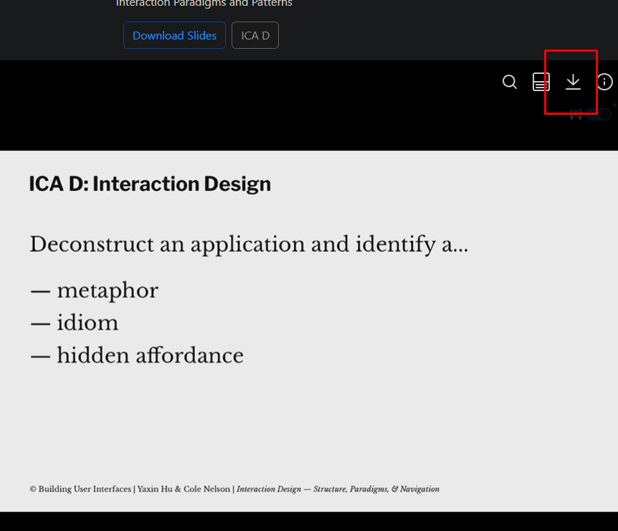
- The down arrow always means “download”

- Do you know of any hidden affordances utilized by the application? If so, what are they?
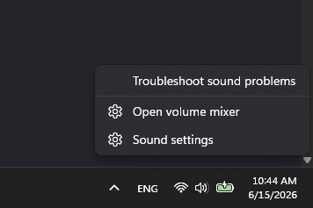
- Left click on the date and time open them, but right click open an options menu

2. Using Navigation Aids and Models for Prototyping

Having just learned navigation models and aids, it’s your turn to develop a prototype using Figma! Figma is a tool used to turn a set of screens into an interactive prototype.

Your Turn! Develop a prototype, either for the desktop or a mobile device, for the Madison Cat Project using Figma. This prototype should allow users to (1) view available cats (2) see details about particular cats and (3) schedule an appointment to see a cat. You do not need to show every cat nor have details for every cat. However, your prototype should be developed enough to clearly get your idea and design across. I’d expect your prototype to have 4-6 interconnected screens. Following, answer the following questions…

- Please paste a public link to your Figma drawing below as well as a screenshot of the overview of all the screens.
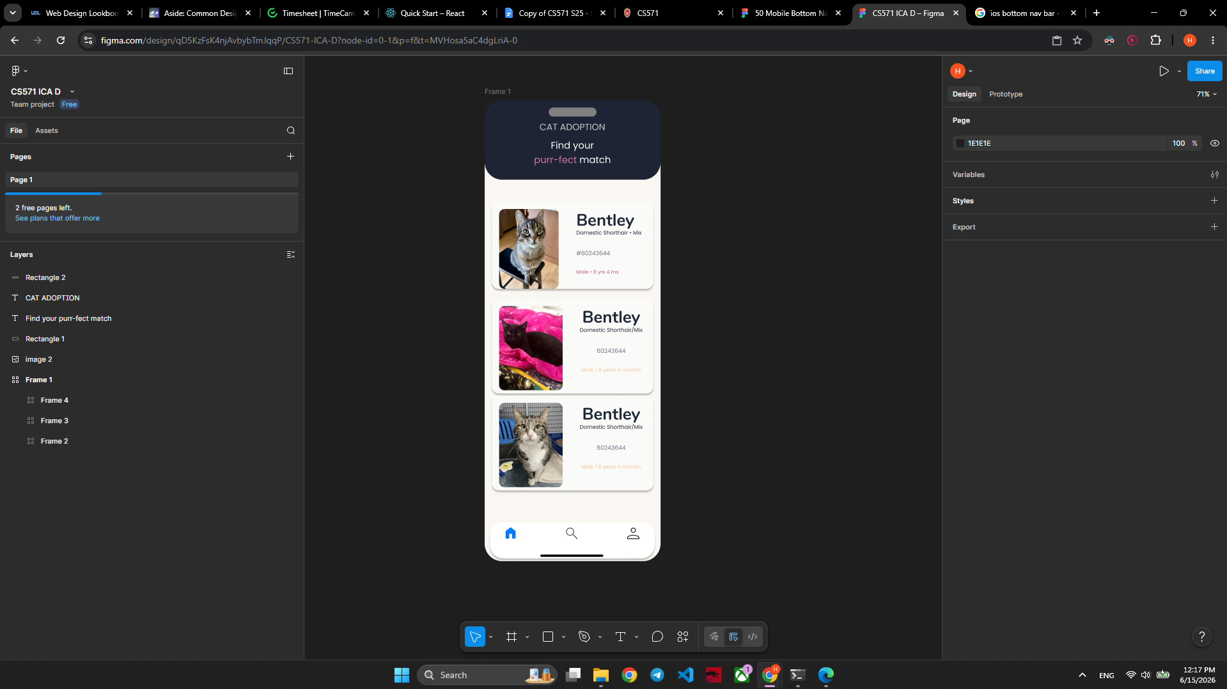

- What kinds of navigation aids did you add to your prototype? How are they used?
- Bottom navigation bar
- Which navigation model(s) did you use? Why did you use them?

After completing this document, please be sure to upload it as a PDF in Canvas!

